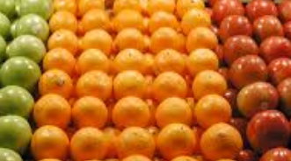
CS 1010 Lab2 – Fruit
10 Points
Due: 9/14 (class time or before) BG Fruit Stand

Propose:
In this project, you will write a complete Python program. This project will help you to practice use of variables, arithmetic operation and output in a Python program.

Instructions (Ask for guidance if necessary):
- To speed up the process, follow these steps.
  - Download the ###lastnamelab2.py and ###lastnamelab2.docx onto your desktop (use your class code for ### and your last name)
  - Launch Pyscripter and open the .py file from within Pyscripter.

- Add your class code and name to the comments at the top as following:
#Name : ###YourLastNames

- This Python program will complete the following program description
You are asked to write a program to calculate the cost of purchasing fruit. The user will input the amount of apples and oranges purchased by the pound. Your program will then calculate and display output shown below. Apples cost $1.25 per pound while oranges cost 1.75 per pound. The sale tax is 7%. You will use UPPERCASE symbolic identifiers for the two prices and the tax rate.

- Write the code:
- You must initialize all variables needed.
- Complete the input section (input the amount of apples and oranges by the pound)
- Complete the processing section (calculate the each value shown below in the output)
- Add the output statement (see screen shot below)
      - Use format for display two digits (see output below.)

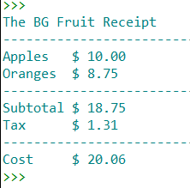
5. Select Run | Run to execute your project
Input: How many pounds of apples: 8 Output:
How many pounds of oranges: 5

6. Open the renamed ###lastnamelab2.docx file and copy your output into the file using the snipping tool
- if you can’t see the entire output, drag the code window up by clicking on the dots in the middle(see lab1)

7. Upload your files unto canvas (DO NOT ZIP)
a. Save and close everything
b. Open your mybgsu portal and navigate to your cs1010 class on canvas
c. Click on the Assignment tab and then the Lab2 link.
d. Select the upload option and upload your both files.

